**Basics** & **Opening Range Concept**

Index Trading Basics

S&P 500 E-Mini Sep '17(ESU17)

2,448.75+1.25 (+0.05%) 17:45CT [GBLX]

2,448.50X 84 2,448.75X 73

ALL FUTURES CONTRACTS for Tue,Jun20th,2017

Set Alerts twatchlist

Intraday

.,,

MainView

.,,

l'r,1Jc S)mhol: IFS! F-mini S&P 500

hading Session: New York Session 9:30 am to 4:00 pm

ContrJl"l l>din·ry l\1onths:

|  |  |  |  |  |  |  |
| --- | --- | --- | --- | --- | --- | --- |
|  | Contract | Last | Change | Open | High | Low |
| + | ESYOO(Cash) | 2, 53. 6 | * 20.31 | 2, 2.55 | 2, 53.82 | 2,441.79 |
| + | E5U17 (Sep '17) | 2,448.75 | * 1.25 | 2, 7.75 | 2, 9,00 | 2, 7,50 |
| + | ESZ17 (Dec '17] | 2,446.50 | +1.50 | 2, 5.25 | 2, .50 | 2, 5.25 |
| + ESH18(Mar '18) 2,443.25s •16.45 2,432.75 2,446.25 2, 32.75 | | | | | | |

\mount l'l'r I ilk,:

I:'.-;o [ll. *:,-;* I n, \-;0_()0 pn onv point.

\'i0.00, S \:P 'illtl lndn

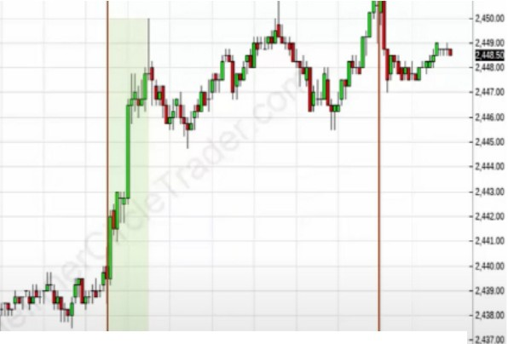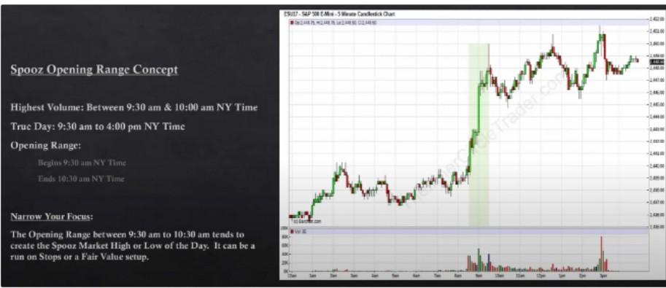

***L***_-l\;_-,'tfi,''''1' 1·J · Tro,D,yB,gin

::■wa

Tn1 Day End

- --

........_....u... ...i......- ... jl

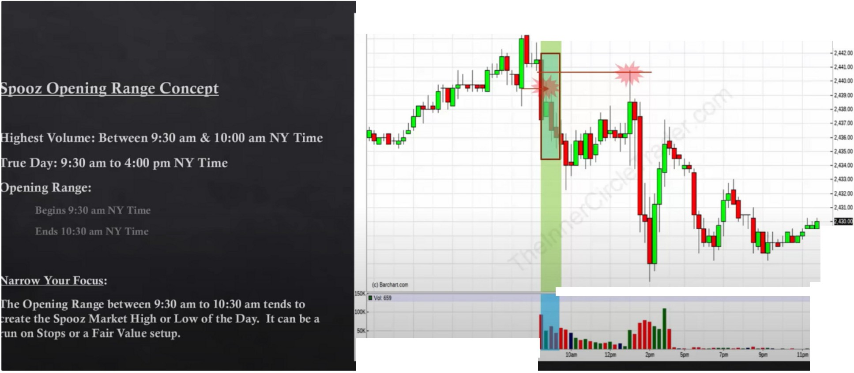

ESIJ1J.S&P500E.Ml-111**L5MinuleCanclesbd:Char1**

* Oll.2.'21.50IU.Q:l.25Lo.2,0.50CU,QUIO

*,*

-vuoo

-_l.,0.0..0,

-J.'2700

*.*

*,.,.*

-i..aoo

**Cit-u- -** • ***la*** ·

-

... ..

···-•···

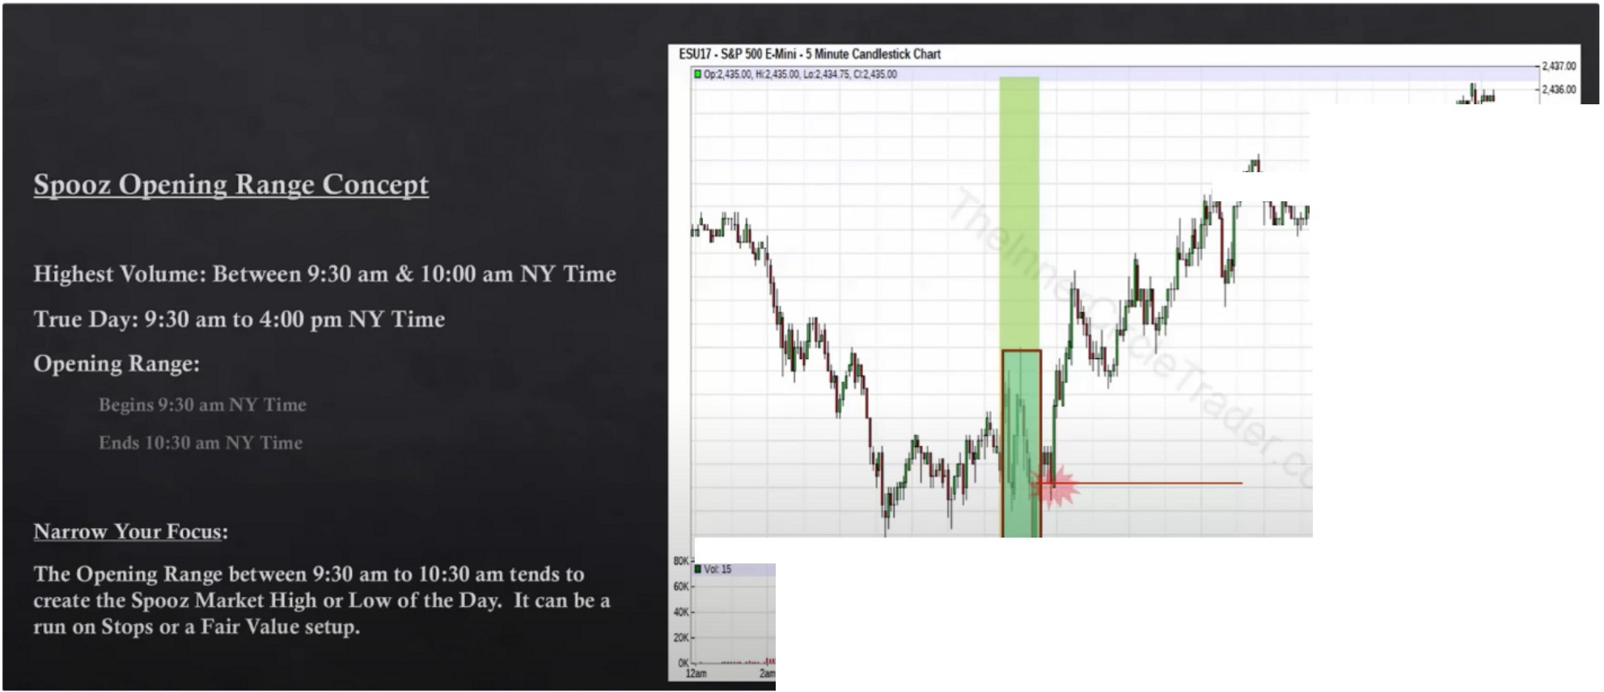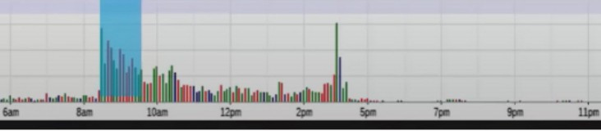

***11.i,,,* M.,,**

***.1·...,.***

I '

***)***

**'i'I, ·**-**lli**,**li**

**"'2,UJOO**

**-2.Ul.CO**

* **2,Gl.00**

**-2,GOCO**

**-2.000**

**•2.aBCD**

**-2.cnao**

**j =-=**

* **2.'2400**

**-z..m.oo**

**•2.'2'2.00**

**•2,'21.00**

**•2,'2000**

**•2,'1!00**

**-2.UI.CO**

**-Hl.700**

**= ---- cJ,.......J =2.•a.00**

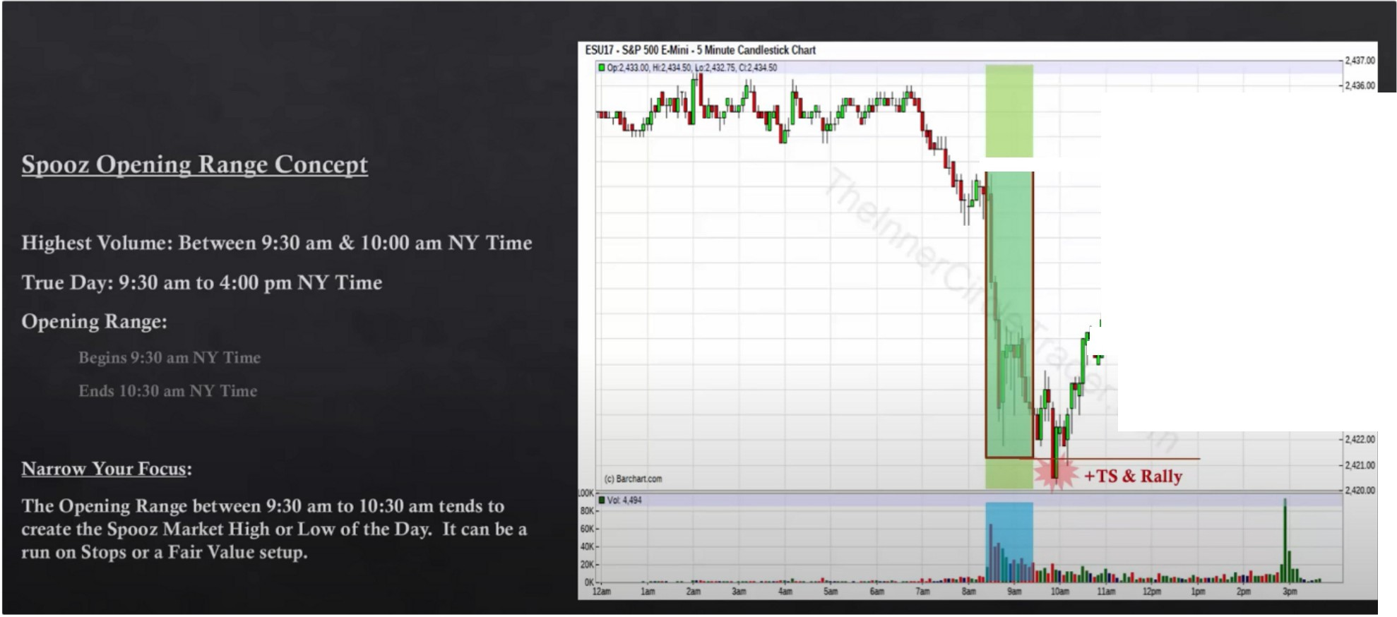

**-2,'15.t.O**

**111111**

**-2..Q&.00**

**.---, f--""·'**"'

'

. ·.*I*

**-2.«00**

**-2,425.00**

**-2.'2'-00**

**-2,42100**

When we have an extended range so a very long range 1 sided, generally we look for the high and or low to be violated later in the day, if its going to be a bullish day we look for that high to be violated or traded to. Reverse for when we expect a bearish day and the opening range primarily is a big move up then we would look for the opening range low to be traded to.

The extension of the opening range will give us a range to reach back into and look for stops on the opposite end

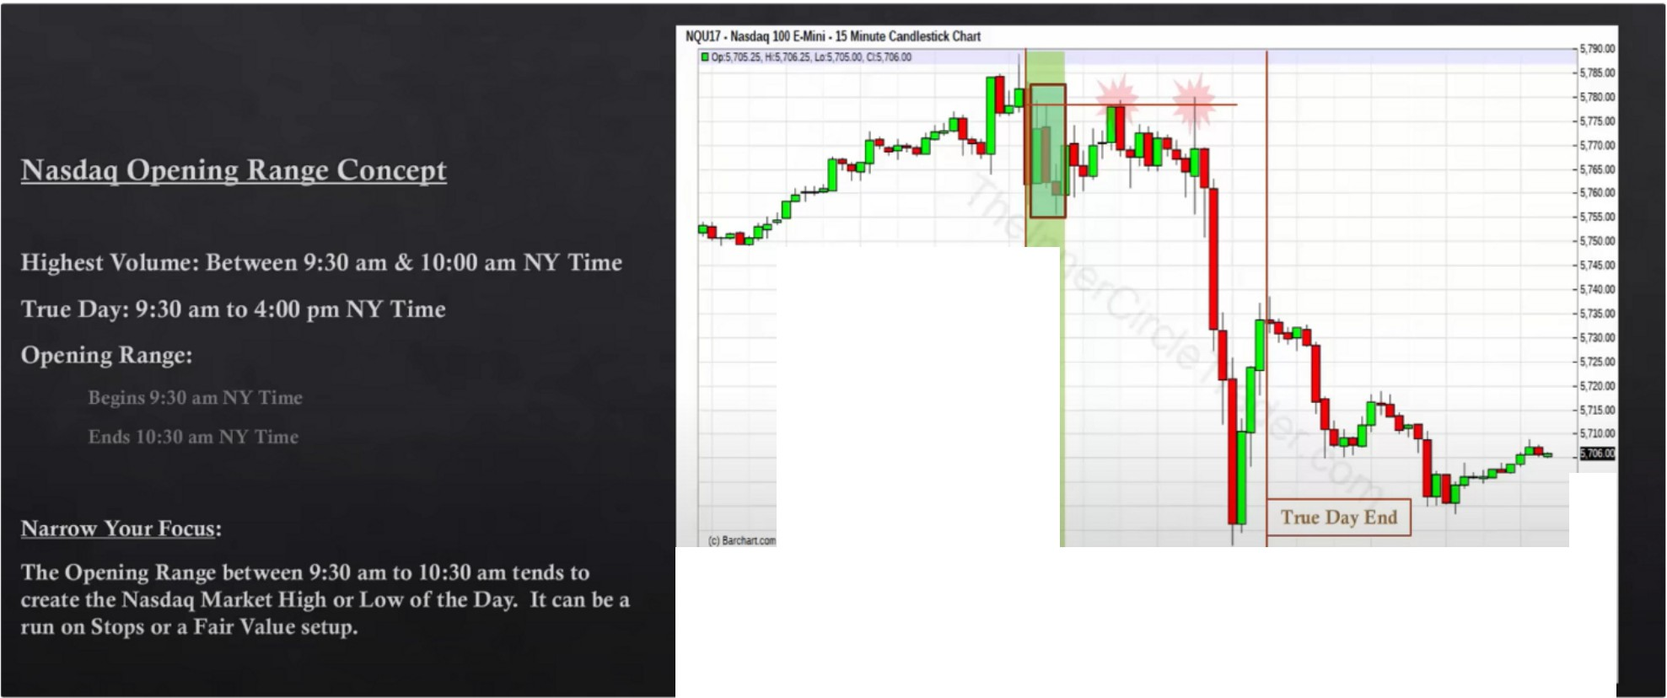

**s.10000**

**True Day Begin**

**D-**■**Vlll21**

**-s.•oo**

**-5'9000**

**---s•m**

:u **-···•- ··11111t---------..** ,""'

Opening is the same for the other 2 indexes

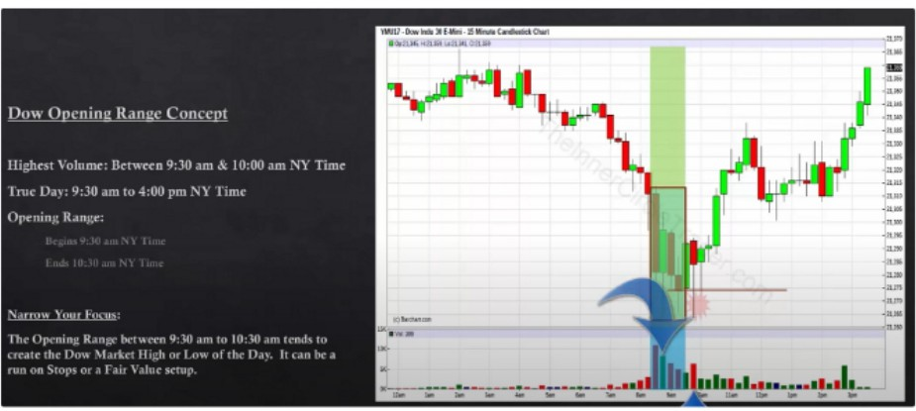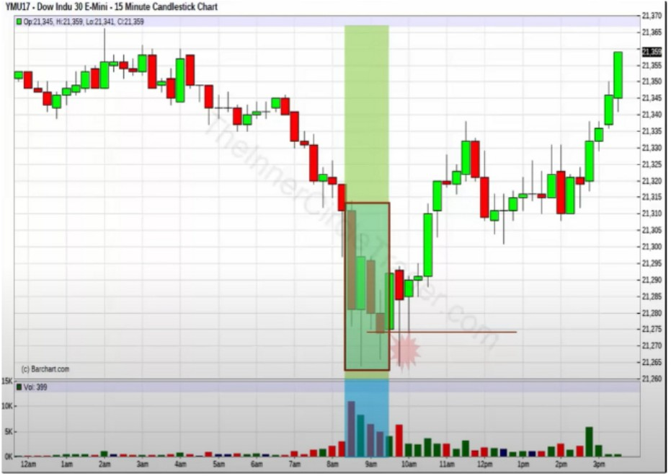

Not enough volume for the second wick to reach below the opening range wick

In futures, volume precedes price so if were going to make a new low or retesting an old low or high it should be seen with higher volume and if its not it means volume is preceding price and its not as strong as it otherwise would look, that second wick would be scary to see without the volume, but with the volume we can see its not as scary. If the volume was higher then we couldve expected the lower wick to be ran out

Were also going to start bledning indices together to get stronger signals for out bias and were going to be looking at specific times of day that are unique for trading indeces

When we have the opening range defined and we have the bias and **HTF** nstitutional orderflow, the opening range will give us support and resistance levels, but theres a very specific relationship to the first hour high and low and the first 30 minutes high and low

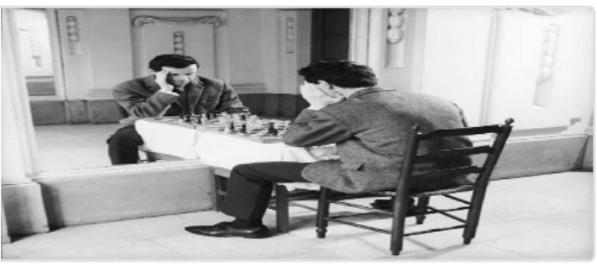Arjo I Twitter, lnstagram I Linktree

Linktree. Make your link do more. https://t.co/HhmmTN1fUI

JavaScript is not available.

"If# https://twitter.com/arjoio